DSA BOOTCAMP ASSIGNMENT

Q1. Write a program to Swap to two numbers.

Code:

#include<iostream>
using namespace std;

int main(){
int num1;
int num2;
int temp;

cout<<”Type value of number1 :”;
cin>>num1;

cout<<”Type value of number2 :”;
cin>>num2;

temp = num1;
num1 = num2;
num2 = temp;

cout<<”After swapping values”<<endl;
cout<<”Value of number 1 : ”<<num1<<endl;
cout<<”Value of number 2 : ”<<num2;
return 0;
}

Output:

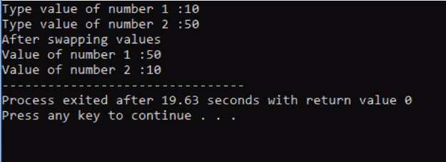

Q2. Write a program to find the largest number among three numbers entered by the user.

Code:

#include<iostream>
using namespace std;

int main(){
int n1,n2,n3;
cout<<”Enter three numbers: ”;
cin>>n1>>n2>>n3;

if(n1>=n2 && n1>=n3){
cout<<”Larger number: ”<<n1;
}
if(n2>=n1 && n2>=n3){
cout<<”Larger number: ”<<n2;
}
if(n3>=n1 && n3>=n2){
cout<<”Larger number: ”<<n3;
}
return 0;
}

Output:

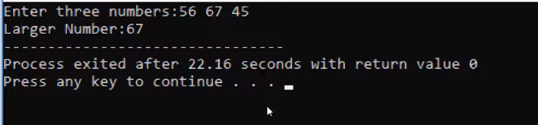

Q3. Write a program to check whether a year entered by a user is Leap year or not.

Code:
#include<iostream>
using namespace std;

int main()
{
int year;
cout<<”Enter a year: ”;
cin>>year;

if(year % 4 == 0){
if(year%100 == 0){
if(year%400 ==0)
cout<<year<<”is a leap year.”;
else
cout<<year<<”is not a leap year”;
}
else
cout<<year<<”is a leap year.”;
}
else
cout<<year<<”is not a leap year.”;
}

else
cout<<year<<”is not a leap year”;
return 0;
}

Output:

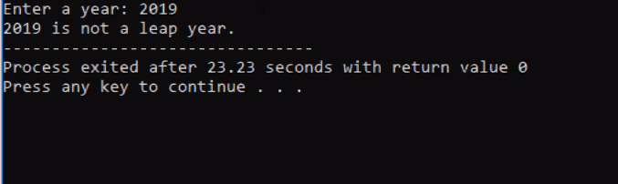

Q4. Write a program to display Fibonacci Series upto nth term. (Using loops)

Code:
#include<iostream>
using namespace std;

int main(){
int n, t1=0, t2=1, nextTerm = 0;
cout<<”Enter the number terms :”;
cin>>n;

cout<<”Fibonacci Serise: ”;

for(int i=1; i<=n; ++i)
{
if(i==1){
cout<<” “<<t1;
continue;
}

if(i==2){
cout<<t2<<” “;
continue;
}
nextTerm=t1+t2;
t1 = t2;
t2 = nextTerm;
cout<<nextTerm<<” “;
}
return 0;
}

Output:

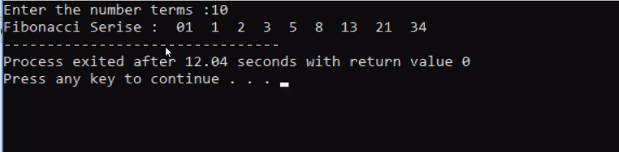

Q5. Write a program to check whether a number is Prime or Not.

Code:
#include<iostream>
using namespace std;

int main(){
int n, i;
bool isPrime = true;

cout<<”Enter a positive integer :”;
cin>>n;

for(i=2; i<=n/2;++i){
isPrime = false;
break;
}
}
If(isPrime)
cout<<”This is a Prime Number”;
else
cout<<” This is not a Prime Number”;
return 0;
}

Output:

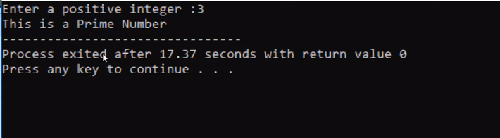

Q6. Print this pattern using loops
For n=5
*
* *
* * *
* * * *
* * * * *

Code:
#include<iostream>
using namespace std;

int main(){
for(int i=1; i<=5; i++){
for(int j=5; j>I; j++)
cout<<” “;
}
for(int k=1; k<=5; k++){
cout<<;
}

return 0;
}

Output:

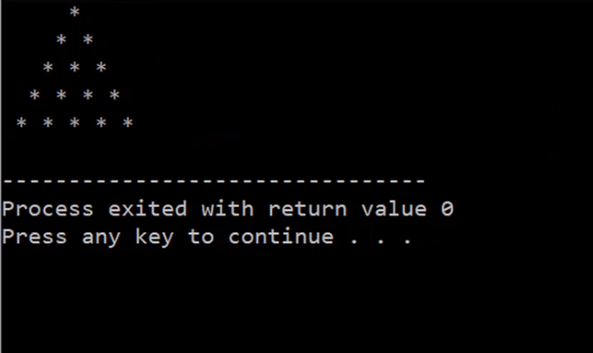

Q7.Write a program that takes n elements from the user and displays the second largest element of an array.

Code:
#include<iostream>
using namespace std;
int main(){
int n, i;
cout<<”Enter number of elements in an array \n”;
cin>>n;

int arr[n];
cout<<”Enter values in an array \n”;

for(i=0; i<n; i++){
cin>>arr[i];
}

int max = INT_MIN;
int second_max = INT_MIN;

for(i=0; i<n; i++){
if(arr[i]>max){
second_max = max;
max = arr[i];
}
if(arr[i] <max && arr[i]>second_max){
second_max = arr[i];
}
}
cout<<”Second highest number in an unsorted array is”<<second_max;
return 0;
}

Output:
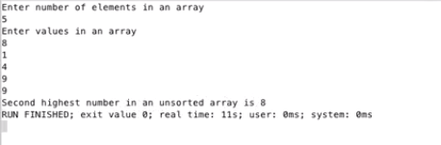

Q8. Left Rotation

Code:
#include <cmath>
#include <cstdio>
#include <vector>
#include <iostream>
#include <algorithm>
using namespace std;

int main() {
/* Enter your code here. Read input from STDIN. Print output to STDOUT */
int n,d;
cin>>n>>d;
int a[n];
for(int i=0;i<n;i++){
cin>>a[i];
}
for(int i=d;i<n;i++){
cout<<a[i]<<" ";
}
for(int i=0;i<d;i++){
cout<<a[i]<<" ";
}
return 0;
}

Output:

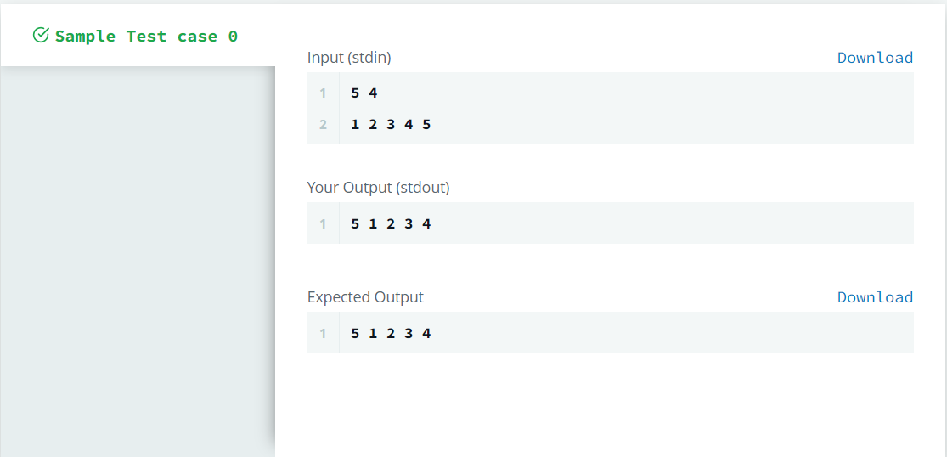

Q9. Grading Students

Code:
#include <bits/stdc++.h>

#define lli long long int
#define pb push_back
#define pii pair <int, int>
#define pll pair <lli, lli>
#define _F first
#define _S second
#define mset(x) memset(x, 0, sizeof(x))
#define fastio() ios_base::sync_with_stdio(0)

using namespace std;

int main()
{
int t;
cin >> t;

while(t--)
{
int x;
cin >> x;

if(x < 38)
cout << x << endl;
else
{
int r = 5 - (x % 5);

if(r < 3)
x += r;

cout << x << endl;
}
}
}

Output:
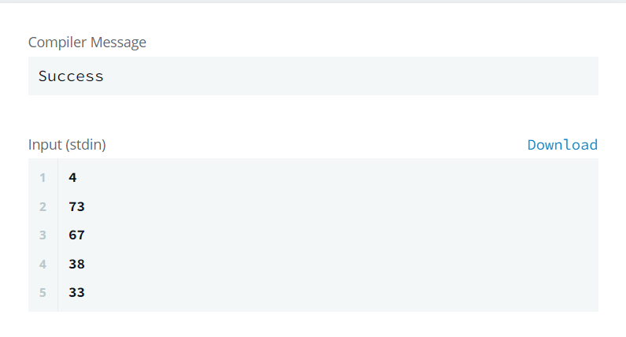

Q10. CamelCase

Code:

#include <iostream>
#include <cstring>
#include <limits>
#include <iomanip>
#include <cmath>
#include <fstream>
#include <map>
#include <algorithm>
#include <iterator>
#include <vector>
#include <set>
#include <cassert>
#define LL long long
#define vi vector<int>
#define vll vector<LL>
#define FOR(i,c) for(__typeof(c.begin()) i = c.begin(); i != c.end(); i++)
#define F first
#define S second
#define smax(a, b) a = max(a, b)
#define smin(a, b) a = min(a, b)
#define mod 1000000007ll
#define what_is(x) cout<<#x<<" is "<<x<<'\n'
#define pii pair<int, int>
#define pll pair<LL, LL>
#define pil pair<int, LL>
#define pli pair<LL, int>
using namespace std;
template<typename T> T gcd(T a, T b) { return b == 0?a: gcd(b, a % b); }
template<typename T> T LCM(T a, T b) { return a*(b/gcd(a, b)); }
template<typename T, typename S> T expo(T b, S e, const T &m){if(e <= 1)return e == 0?1: b;\
return (e&1) == 0?expo((b*b)%m, e>>1, m): (b*expo((b*b)%m, e>>1, m))%m;}
template<typename T, typename S> T expo(T b, S e){if(e <= 1)return e == 0?1: b;\
return (e&1) == 0?expo((b*b), e>>1): (b*expo((b*b), e>>1));}
template<typename T> T modinv(T a) { return expo(a, mod-2, mod); }
template<class T, class S> std::ostream& operator<<(std::ostream &os, const std::pair<T, S> &t) {
os<<"("<<t.first<<", "<<t.second<<")";
return os;
}
template<class T> std::ostream& operator<<(std::ostream &os, const std::vector<T> &t) {
os<<"["; FOR(it,t) { if(it != t.begin()) os<<", "; os<<*it; } os<<"]";
return os;
}
int main() {
ios_base::sync_with_stdio(false);
int res = 0;
string s;
cin >> s;
for(auto &elem: s) {
if(elem >= 'A' and elem <= 'Z') {
res++;
}
}
cout << (res + 1) << endl;
return 0;
}

Output:

